news +++ EMV Seminars
Leinfelden-Echterdingen, 20 – 22 October 2026


EMV Seminars 2026: Three days, six seminars, countless practical insights
Stuttgart, 2 September 2026. Taking place from October 20 to 22, 2026, in Leinfelden-Echterdingen, near Stuttgart, the EMV Seminars offer a compact further education program for specialists and managers in development, design, quality assurance, and conformity assessment in the field of electromagnetic compatibility. Participants can choose from six practice-oriented one-day seminars to create a further education program that addresses their professional challenges.
The concept behind the EMV Seminars event is to combine in-depth technical knowledge with direct, practical relevance. In small groups, participants benefit from personal interaction with industry and academic experts, discuss specific issues from their day-to-day work, and receive applicable solutions.
"This combination of knowledge transfer, practical relevance, and networking makes the EMV Seminars a valuable form of further education for everyday professional life," comments Jeannette Meyer, Vice President EMV at Mesago Messe Frankfurt.
The Seminars program is structured as follows:

Day 1: EMC fundamentals and modern simulation methods
The first day of the event features two special highlights. At the seminar, "Practical EMC Fundamentals for Developers and Engineers," Würth Elektronik will provide a comprehensive overview of electromagnetic compatibility and offer practical solutions to common development challenges.
"Many EMC problems can be avoided if the relevant factors are considered in the early stages of development. In our seminar, we cover the most important EMC fundamentals using concrete, real-world application examples and demonstrate how developers can identify typical sources of interference early on and integrate effective countermeasures directly into their designs," explains Adrian Stirn, Technical Lead at the EMC laboratory at Würth Elektronik.
International participants are invited to join the English-language seminar: “EMC Simulation of Electronic Systems – From Modeling to Machine Learning”, which will be presented by Prof. Dr. Jan Hansen from the Graz University of Technology. The seminar is to provide valuable insights into state-of-the-art simulation methods, advanced modelling techniques and the increasing impact of machine learning on EMC engineering. Attendees will learn how innovative, data-driven approaches can support the prediction, analysis and optimization of electromagnetic compatibility throughout the product development process, helping organizations accelerate development cycles and improve product reliability.

Day 2: Standards and shielding solutions
On the second day of the seminar, the focus will be on current developments in the IEC 61000 and CISPR standard series and their practical implementation. Dr. Bernd Jäkel of Jäkel EMC Consulting summarizes the content of the session as follows:
"Participants will gain a practical overview of current EMC standard developments and their impact on test procedures and conformity assessments. Additionally, we will examine the specific situation regarding CE marking and opportunities to influence future standards."
Furthermore, participants will learn when enclosure shielding can be used effectively and what alternative solutions are available for reducing electromagnetic interference. Thus, the seminars provide both regulatory knowledge and concrete technical solutions for practical application.

Day 3: Successfully implementing EMC and CE Compliance
On the third day of the event, participants will learn how to successfully integrate EMC and CE requirements into the product development process. They will also learn how to prevent and analyse malfunctions in large machines and industrial systems. Participants will receive specific recommendations to reduce development risks, streamline approval processes, and resolve typical EMC issues in industrial settings effectively.

After-Work Event at IAV's EMC Testing Center
In addition to the technical seminars, the after-work event on October 21, 2026, starting at 6:00 p.m., provides an opportunity to network with other members of the EMC community. IAV GmbH will host the gathering in Heimsheim at its EMC testing center, which combines state-of-the-art testing technology in a historic atmosphere. Highlights include a 10-meter vehicle absorber hall with a roller test bench, replicas of AC grid topologies from around the world, and a component test chamber for validating electric drives and power electronics. You can register for the after-work event online via the EMV website.

Reserve your spot in the seminar now
The 2026 EMV Seminars offer suitable further education for beginners and experienced professionals alike, whether they're interested in foundational knowledge, the latest developments in standards and simulation methods, CE conformity, or industrial applications. Further information on the complete seminar program and registration details can be found on the EMV website.

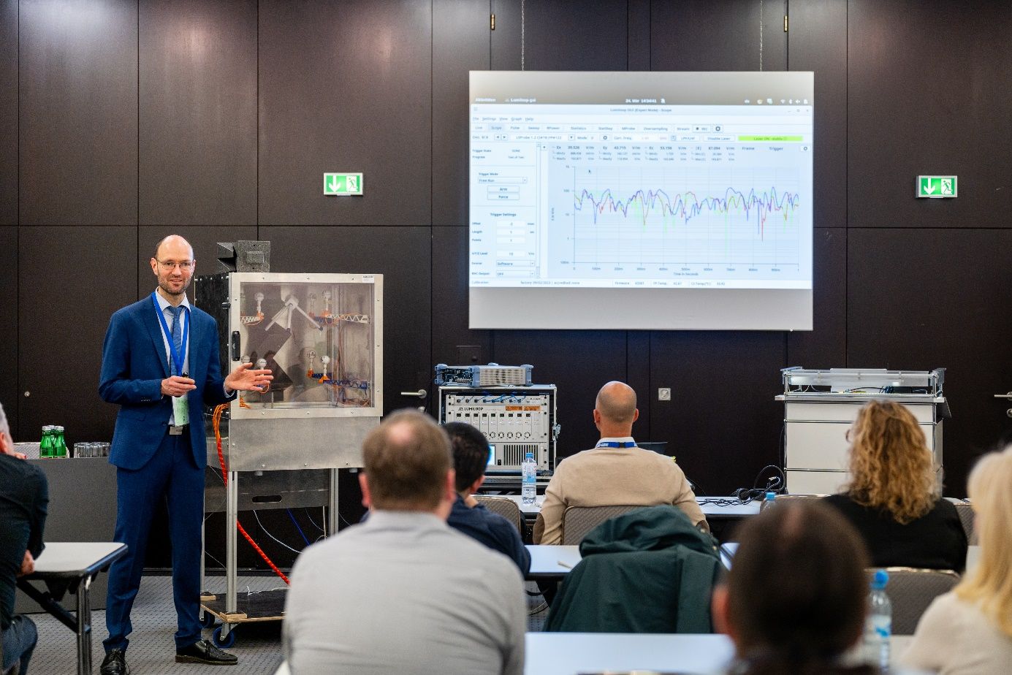
Copyright: Mesago Messe Frankfurt GmbH / Mathias Kutt
EMV Seminars
All-day seminars on Electromagnetic Compatibility (EMC)
The EMV seminars will be held from 20 – 22 October 2026.

Press information and photographic material:
Press releases - EMV Seminars

Links to websites:
EMV Seminars - EMC knowledge for your everyday professional life

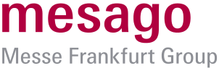

Your contact:
Jeannette Meyer
Phone: +49 711 61946-290
Jeannette.Meyer@mesago.com
Mesago Messe Frankfurt GmbH
Rotebuehlstraße 83 -85
70178 Stuttgart
Germany
www.mesago.com

Background information on Mesago Messe Frankfurt GmbH
Since 1982, Mesago Messe Frankfurt GmbH has specialized in creating B2B formats for specific technology topics. Having originally emerged from the trade fair and congress sector, the company now offers much more than internationally established technology events. Thanks to the consistent development of its portfolio, Mesago connects leading players worldwide through innovative platforms in the form of industry-specific technology hubs, available 24/7, 365 days a year. Alongside traditional expos and conferences, these hubs comprise digital events, in-depth knowledge formats, and comprehensive services that are tailored to the specific requirements of individual industries.
These hubs create a dynamic space for a timely exchange of information and technological innovation, providing a year-round flow of content. With a view to the ever-changing needs of trade communities, Mesago creates ideal conditions through its forward-looking formats, primarily to further develop an even more efficient global network and to ensure that it is always up to date with the latest developments. This is true to the company's motto: 'Connecting bright minds'.
As part of the Messe Frankfurt Group, Mesago employs around 170 people at its headquarters in Stuttgart, Germany. (mesago.com)

Background information on Messe Frankfurt
www.messefrankfurt.com/background-information

Sustainability at Messe Frankfurt
www.messefrankfurt.com/sustainability-information

