Title (style: title; Arial 14 pt, bold, left-aligned)
Academic Title, first name, last name, company, country of speaker
Academic Title, first name, last name, company, country of co-speaker (workshops only)
Academic Title, first name, last name, company, country of co-author (conference only)
Other co-authors or co-speakers below with the same information, each in a new line (style: authors; Arial 11 pt, left-aligned) (add or delete lines if necessary)

Main heading 1 (style: heading 1; Arial 11 pt, bold, left-aligned)
Start here with the abstract (style: standard; Arial 11 pt, justification). Graphics, tables etc. can also be inserted here.
Insert references via cross-reference.

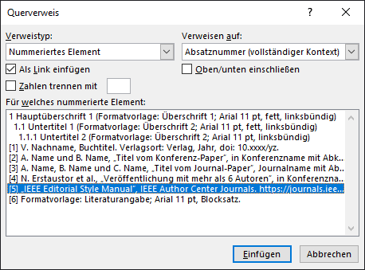
Figure 1: Screenshot of the cross-reference menu window
For more information on citing sources, see the IEEE Reference Guide [6].
Finally, reference is made to the example table 1.

Table column head | Table column head
Table content | Table content
Table content | Table content
Table content | Table content
Table 1: Example of a table caption
Examples of headings are shown below. Good luck with your writing project!

Subtitle 1 (style: heading 2; Arial 11 pt, bold, left-aligned)
Here you can insert intermediate topics (style: standard; Arial 11 pt, justification).

Subtitle 2 (style: heading 3; Arial 11 pt, left-aligned)

Subtitle 3 (style: heading 4; Arial 11 pt, left-aligned, italics)
Text for the next sub-item (style: standard; Arial 11 pt, justification).

Main part / Method / Investigation
Captions of the figures should be labeled as shown below:
Figure 1: Caption (style: caption; Arial 10 pt, left-justified, with a lot of text justified)

Tables should be labeled as shown below:
Table 1: Table caption (style: caption; Arial 10 pt, left-justified, with a lot of text justified)

Results / Conclusion
Write down your conclusion here.
Note on conference contributions: At this point, state the results and how new these are.

Literature
- style: bibliography; Arial 11 pt, justified.
- V. last name, book title. Place of publication: Publisher, year, doi: 10.xxxx/yz.
- A. last name und B. last name, ”Title from the conference paper“, in Conference name with IEEE abbreviations, place of conference, year, S. xx-xy, doi: 10.xxxx/yz.
- A. last name, B. last name und C. last name, ”Title of journal paper“, journal name with abbreviations according to IEEE, vol. XX, no. YY, pp. xx-xy, month, year, doi: 10.xxxx/yz.
- N. principal author et al., “Publication with more than 6 authors", in Proceedings of EMV 2022, Cologne, 2022, pp. 100-101, doi: 10.15488/10002.
- ”IEEE Editorial Style Manual“, IEEE Author Center Journals. https://journals.ieeeauthorcenter.ieee.org/your-role-in-article-production/ieee-editorial-style-manual/ (accessed dd month yyyy)

