news +++ EMV
Cologne, 24 – 26 March 2026

The EMV 2026 successfully concluded – stands out with internationality and depth of expertise
Stuttgart, 26 March 2026. The EMV 2026 has come to a successful close, once again confirming its position as the premier platform for electromagnetic compatibility worldwide. This year's Expo in Cologne featured 124 exhibiting companies, covering 4,700 square meters of exhibition space and attracting 2,414 visitors. The event included an extensive training program with 42 lectures and 20 workshops, with a total of 571 participants. These figures clearly demonstrate the strong impact of the EMV, particularly given the high level of interest from abroad.
International participation at the EMV was greater than ever this year. Fifty percent of exhibitors and 30 percent of visitors and participants traveled from numerous countries. The event once again combined further education with networking and hands-on experience with the latest product developments and measurement solutions in the field of electromagnetic compatibility.
"This year's EMV once again demonstrates the importance of the interplay between research, industrial application, and regulation," emphasized Jeannette Meyer, EMV Vice President at Mesago Messe Frankfurt. "The technical depth of all program areas and the broad participation from many countries have noticeably enriched the exchange. The EMV Expo thus remains a central point of reference for anyone who wants to stay up to date in the field of electromagnetic compatibility."

From the big picture to industry trends: EMV 2026 set the tone in terms of content.
The strong turnout was reflected in the diversity of topics covered at the Conference, Workshops, and Expo. These events clearly demonstrated the close link between current developments in power electronics, the energy transition, the Internet of Things (IoT), and smart system integration, as well as the great need for expert guidance in this dynamic environment.

"In an era of increasingly decentralised and interconnected large-scale systems that can adversely affect one another, products, standards and technologies must be refined in ever shorter cycles to meet these new demands. We also need a platform where knowledge can be shared transparently and challenges solved collaboratively. The EMV is precisely such a platform: it brings experts together, promotes open exchange, and ensures that new findings are quickly incorporated into the industry’s development and testing processes. This is where EMC expertise is becoming increasingly important. That is why the EMV Expo and Conference has long since become a key driving force for the entire professional community,” emphasises Prof. Heyno Garbe, Chair of the EMV Committee.

The exchange of expertise between industry, research and users demonstrated the high level, especially with regard to future topics such as EMC in power electronics and smart system integration.

'We’ve once again achieved our main objectives this year. First, meeting test labs and speaking with experts – which we’ve successfully done. Second, connecting with other members of this specialized community, which is always very important. And third, exploring product developments from the past twelve months – and there have been many worth seeing. In Europe, the EMV is the only event that brings together so many global players in this field. For us, this annual event is essential.,' explains Julien Sarrade, Business Development Manager General Electronics, EMEA, Keysight Technologies.

Highlights of the EMV 2026
Participants at this year's EMV could expect a diverse programme of presentations at the congress sessions and workshops, as well as at the trade fair forum, with various highlights. Whether they were students, EMC beginners, or C-level development managers, there was something for everyone.

Premiere: ‘Experiments & Live Demonstrations Session’
For the first time, the EMV offered its own session comprising three live demonstrations of real measurement setups, sources of interference, coupling mechanisms, and countermeasures. This format particularly met the needs of developers, test engineers and users with strong practical experience.

“The new Experiments & Live Demonstrations Session is a highly valuable addition to the EMV, bringing hands-on innovation into the spotlight. The demo format encourages more natural discussions and collaboration between academia and industry, making it easier to adopt new techniques. Exposure to real-world problem-solving approaches format makes the event more engaging and valuable, especially for students and practitioners who live validation of concepts,” explains Vignesh Rajamani, Application Segment Manager, EMC
Rohde & Schwarz USA, Inc.

Inspiring keynote: EMC compliance in the age of AI
Another highlight was the keynote address, which for the first time shed light on the interactions between regulatory requirements for AI-based systems and EMC compliance. The introduction of adaptive, intelligent systems is creating new testing and documentation requirements, a topic which met with great interest.

Outlook
The EMV thus remains the central meeting place for everyone working at the interface of research, development, and application in the field of electromagnetic compatibility. Further information about the Expo and additional offerings, such as on-demand knowledge formats, is available year-round on the Hub for Electromagnetic Compatibility, the platform for the EMC community.

The next EMV will take place in Stuttgart from 27 to 29 April 2027.

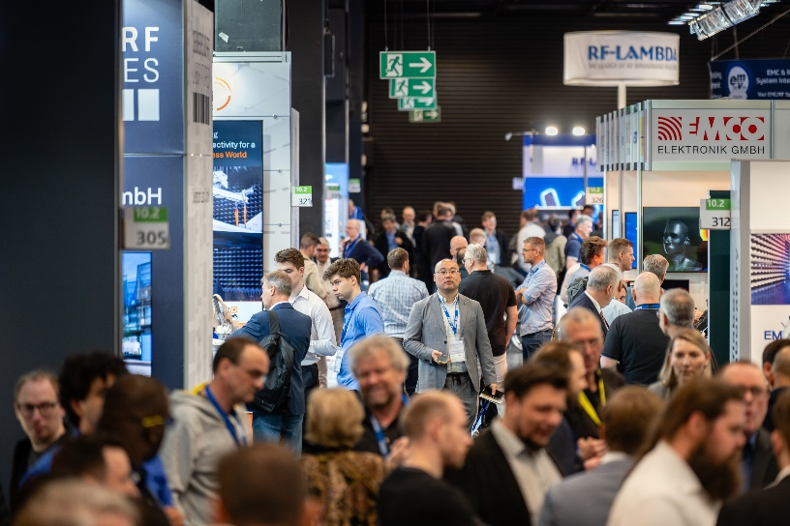
Copyright: Mesago Messe Frankfurt GmbH / Matthias Kutt
EMV
International exhibition with workshops on Electromagnetic Compatibility
The EMV will be held from 27 – 29 April 2027.

Press information and photographic material:
Press - EMV

Links to websites:
EMV – Hub for Electromagnetic Compatibility https://www.linkedin.com/showcase/emv---international-exhibition-on-electromagnetic-compatibility-emc-

Your contact:
Jeannette Meyer
Phone: +49 711 61946-290
Jeannette.Meyer@mesago.com
Mesago Messe Frankfurt GmbH
Rotebuehlstraße 83 -85
70178 Stuttgart
Germany
www.mesago.com

Background information on Mesago Messe Frankfurt GmbH
Since 1982, Mesago Messe Frankfurt GmbH has specialized in creating B2B formats for specific technology topics. Having originally emerged from the trade fair and congress sector, the company now offers much more than internationally established technology events. Thanks to the consistent development of its portfolio, Mesago connects leading players worldwide through innovative platforms in the form of industry-specific technology hubs, available 24/7, 365 days a year. Alongside traditional expos and conferences, these hubs comprise digital events, in-depth knowledge formats, and comprehensive services that are tailored to the specific requirements of individual industries.
These hubs create a dynamic space for a timely exchange of information and technological innovation, providing a year-round flow of content. With a view to the ever-changing needs of trade communities, Mesago creates ideal conditions through its forward-looking formats, primarily to further develop an even more efficient global network and to ensure that it is always up to date with the latest developments. This is true to the company's motto: 'Connecting bright minds'.
As part of the Messe Frankfurt Group, Mesago employs around 170 people at its headquarters in Stuttgart, Germany. (mesago.com)

Background information on Messe Frankfurt
www.messefrankfurt.com/background-information

Sustainability at Messe Frankfurt
www.messefrankfurt.com/sustainability-information

