news +++ EMV
Cologne, 24–26 March 2026

Visit, try out, and progress! Top highlights, innovations, and exciting live formats at the EMV 2026
Stuttgart, 25 February 2026. It's almost time – from March 24 to 26, the EMV 2026 will open its doors in Cologne, once again becoming the central meeting place for the international electromagnetic compatibility community. With its combination of Expo, congress, and workshops, the EMV offers a unique forum that combines practical relevance, further education, and innovation "live."
Interested visitors can expect to see the latest products, technologies, and services from around 120 international exhibitors at the EMV 2026, which will maintain the high standard of last year's event. Key industry players such as Rohde & Schwarz, EMCO, Phoenix Testlab, EMC Test NRW, ETS Lindgren, and Frankonia will be present. The Newcomer Area will also be a special highlight. Eight companies will present themselves at the EMV for the first time, including First Spectrum View and TÜV NORD Hochfrequenztechnik GmbH & Co. KG. The event thus provides an ideal opportunity to learn about new developments in direct dialogue with industry leaders.
Practical support through live analyses
The EMV once again offers companies the opportunity to receive practical support for their unique challenges in the field of electromagnetic compatibility. The focus is on formats that impart knowledge and demonstrate concrete solutions. Various exhibitors will showcase how to identify and optimize typical sources of interference under real conditions. Katja Langer, the managing director of Langer EMV-Technik GmbH, emphasizes her company's contribution to solution-oriented work at the expo:
"The EMV 2026 in Cologne is the central meeting place for us, where electromagnetic compatibility can be experienced firsthand. Under the motto 'Bring it. Test. Optimize," we will analyze the weak points of electronics brought along free of charge throughout the three-day trade fair. With our tools, development-accompanying measurement technology, and experts' know-how, we offer visitors in-depth insights directly at our booth. To ensure a smooth experience, we recommend that interested parties register in advance via our company website."
Congress focusing on AI and future topics
The EMV Congress 2026 offers an extensive and user-friendly program, including eleven thematic sessions and twenty workshops. Participants can design their own training program, whether the focus is on new regulatory requirements or developments in measurement technology. A highlight for expo and congress guests will be the keynote speech, "AI, Radio, and EMC: Potential and Regulatory Aspects," on the first day of the event. Taras Holoyad, a representative of the Federal Network Agency, will provide valuable insights that are particularly relevant to the EMC community:

"AI is already shaping radio and EMC systems today, offering impressive possibilities but also clear limitations. The keynote speech will demonstrate how AI models can be used responsibly and effectively, as well as the crucial regulatory requirements in this context. Attendees will receive an overview of the opportunities, risks, and practical applications that are shaping the future of our technologies.”
This will be followed immediately by a panel discussion entitled "AI in Application: Technical Possibilities and Limitations for EMC." On the second day of the expo, there will be another panel discussion aimed specifically at decision-makers: "Management of Electromagnetic Compatibility in the Context of Product Validation: Between Full Cost Optimization and Risk Management." This discussion will highlight the role of EMC in strategic projects.
New formats in 2026: Experiments, live demonstrations, and roundtables
With the new "Experiments & Live Demonstrations Session" on the last day of the event, the EMV is expanding its program to include a format that allows technical issues to be experienced directly in front of an audience for the first time. The presentation by Lumiloop GmbH, for example, will demonstrate how modern measurement technology can make interference phenomena visible and analyzable. New roundtable sessions promote professional exchange on an equal footing, enabling participants to discuss specific questions with experts from different fields.
The EMV offers the opportunity to discuss current challenges in electromagnetic compatibility, learn about new technologies, and network with experts from various industrial sectors as a combination of trade fair, congress, and workshops. Additional content in the EMV Hub for electromagnetic compatibility promotes the long-term application of ideas gained at the expo and allows specific topics to be explored in greater depth throughout the year.
Information on ticketing and registration
Registration for the expo and congress is available online. Visitor tickets can be ordered at visitortickets.mesago.com. Registration for the congress and workshops takes place via the EMV website. An expo ticket includes access to the entire trade fair, the keynote speech and subsequent panel discussion on the first day of the fair, and all formats of the trade fair forum, including the new sessions.
More information about the EMV 2026, the program, and the EMV Hub is available on the official event website: www.emv.mesago.com.

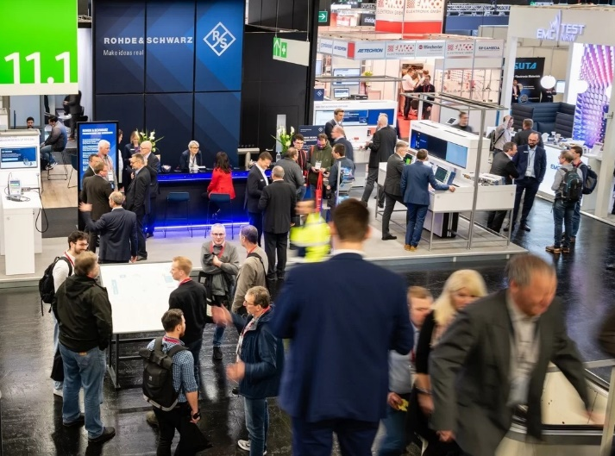
Copyright: Mesago Messe Frankfurt GmbH / Matthias Kutt

EMV
Hub for electromagnetic compatibility
International trade fair with workshops on electromagnetic compatibility (EMC)
The EMV will be held from 24 - 26 March 2026.

Press information and photographic material:
Press - EMV

Links to websites:
EMV – Hub for Electromagnetic Compatibility https://www.linkedin.com/showcase/emv---international-exhibition-on-electromagnetic-compatibility-emc-

Your contact:
Jeannette Meyer
Phone: +49 711 61946-290
Jeannette.Meyer@mesago.com
Mesago Messe Frankfurt GmbH
Rotebuehlstraße 83 -85
70178 Stuttgart
Germany
www.mesago.com

Background information on Mesago Messe Frankfurt GmbH
Since 1982, Mesago Messe Frankfurt GmbH has specialized in creating B2B formats for specific technology topics. Having originally emerged from the trade fair and congress sector, the company now offers much more than internationally established technology events. Thanks to the consistent development of its portfolio, Mesago connects leading players worldwide through innovative platforms in the form of industry-specific technology hubs, available 24/7, 365 days a year. Alongside traditional expos and conferences, these hubs comprise digital events, in-depth knowledge formats, and comprehensive services that are tailored to the specific requirements of individual industries.
These hubs create a dynamic space for a timely exchange of information and technological innovation, providing a year-round flow of content. With a view to the ever-changing needs of trade communities, Mesago creates ideal conditions through its forward-looking formats, primarily to further develop an even more efficient global network and to ensure that it is always up to date with the latest developments. This is true to the company's motto: 'Driving technologies by connecting bright minds'.
As part of the Messe Frankfurt Group, Mesago employs around 160 people at its headquarters in Stuttgart, Germany. (mesago.com)

Background information on Messe Frankfurt
www.messefrankfurt.com/background-information

Sustainability at Messe Frankfurt
www.messefrankfurt.com/sustainability-information

